Optimizing the Scicode Project Operational Workflow

1. Project Overview
The workflow involves two primary projects: SFT (Task Creation) and RLHF (Task Verification).
SFT is dedicated to task management. It covers the full lifecycle of a task, including task assignment, task completion, review, rework, and final readiness.
RLHF is focused on testing model breakability. Trainers claim tasks and evaluate whether the model can be successfully challenged. In the current SFT and RLHF cycles, models such as GPT-5.4 are tested for breakability.
When breakability is successfully identified during the RLHF phase, the process loops back to the SFT project for further referencing, refinement, and task improvement.

2. Task Generation Process
A specialized pipeline has been established to automate the creation of tasks for trainer review. This pipeline is the primary source of task creation and is designed to reduce manual effort while improving task consistency.
In addition to the automated pipeline, there is a secondary provision for empty batches. This is used less frequently but allows trainers to develop tasks from the ground up when required.

3. Automated Workflow for Pipeline Tasks
The automated workflow for pipeline tasks follows the steps below:
- STEM archive collection
STEM archives are collected from various sources, such as Google Scholar and https://arxiv.org/.
- Scientific screening
Optionally:
We can test merging more than one paper for extra complexity.
Think of it this way. Each paper creates a subproblem, and a coherent main problem is created by merging 2+ papers.
Documents are screened to confirm scientific validity and appropriateness for integration into tasks.
- Breakability testing
High-reasoning models, specifically GPT-5.4, are tested for breakability using the curated content.
- Task standardization
Suitable tasks are converted into a standardized format. Main problems are broken down into sub-problems, and each task includes background data, prompts, solutions, and unit tests.
- Directory organization and sync
Finalized task sets are sorted into directories, moved to Google Drive, and synced with the labeling platform.
- Researchers then validate the tasks, making sure the problems ground truth are correct and the tasks are coherent and unambigious.

4. IN RLHF Project
In the RLHF Project, trainers validate tasks by checking pass@k samples for main and subproblems separately. After validation, trainers add the required metadata and supporting information.

Metadata: domain/subdomain can and perplexity links can be added programmatically and verified by researchers.
Some teams also use Google Sheets to capture these metrics, especially when requirements vary across clients. Because the criteria are strict and can differ from client to client, metadata capture must be consistent, traceable, and easy for reviewers to verify.

5. Review Stage
The Review Stage includes L1 and L2 reviews. These reviews are generally performed to check the quality, correctness, clarity, and completeness of the task.
Reviewers verify whether the task meets the expected standard before it moves forward. If issues are found, the task is sent back for rework.
There is also a unified pipeline that runs at the end of the process. This pipeline performs additional checks and assigns rework back to the trainer if any ambiguity is found.

6. People Management
Due to the complexity of the task, the project often sees a high level of attrition. This creates operational challenges, including cases where non performers may be overpaid if tracking and performance controls are not strong enough.
The system currently supports two payment models:
- pay per hour
- pay per approved task
Both models run in parallel to meet project targets. However, stronger workflow visibility is needed to ensure that payments are aligned with task quality, approval status, and actual contribution.

7. Current Workflow Challenges
The current workflow involves multiple manual handoffs across different platforms. This creates inefficiencies and increases the risk of human error.
Trainers often need to switch between task preparation tools and the RLHF Playground to validate breakability. After validation, they must manually return to update metadata, references, and task status.
Reviewers and approvers also spend significant time tracking task status, reviewing prior actions, transferring information across stages, and confirming whether all required checks have been completed.
The major challenges are:
- Manual movement of tasks between systems
- Duplicate effort in updating metadata
- Limited visibility into trainer actions and review history
- Inconsistent tracking of pass@k sample for main and subproblems
- Dependency on Google Sheets for some client-specific metrics
- Manual follow-up for rework assignment
- Risk of tasks moving forward without complete metadata
- Delays between PodLead approval and delivery-ready state
- Limited linkage between payment model, quality outcome, and approved output

8. What Needs to be Streamlined
The overall system should be streamlined by reducing manual handoffs and improving integration between SFT, RLHF Project, RLHF Playground, Review Stage, PodLead approval, and the Tier 1 and Tier 2 QC pipelines.
Trainers should be able to validate, document, and submit tasks within a unified experience. This would reduce the need to move between multiple tools and manually update the same information in different places.
Reviewers should have seamless visibility into prior trainer actions, pass@k sample information, metadata, feedback, rework history, and approvals. This would reduce manual tracking and make the Review Stage faster and more reliable.
Once a task receives PodLead approval, it should automatically progress to the delivery-ready state. From there, the Tier 1 and Tier 2 QC pipelines should perform the final quality checks.
This streamlined flow would reduce turnaround time, minimize errors, improve task traceability, and allow contributors to focus more on task quality rather than administrative processes.

Final Recommended Flow
The recommended optimized flow should be:
Admin generates Scicode tasks from the portal → tasks are stored using Google Drive backend for scicode colabs → Admin adds tasks as a batch → Trainers claim and complete tasks → automated checks validate metadata and completeness → Pod Leads perform reviews, rubrics checks, scoring, and pass@criteria checks → reworks are assigned when required → approved tasks move to Tier 1 and Tier 2 QC pipelines → final approved tasks move into delivery batches → Admin monitors reporting, trainer performance, tickets, and delivery progress.
This creates a single operating system for Admin, Pod Leads, and Trainers while reducing manual handoffs, improving visibility, and making the workflow more scalable.

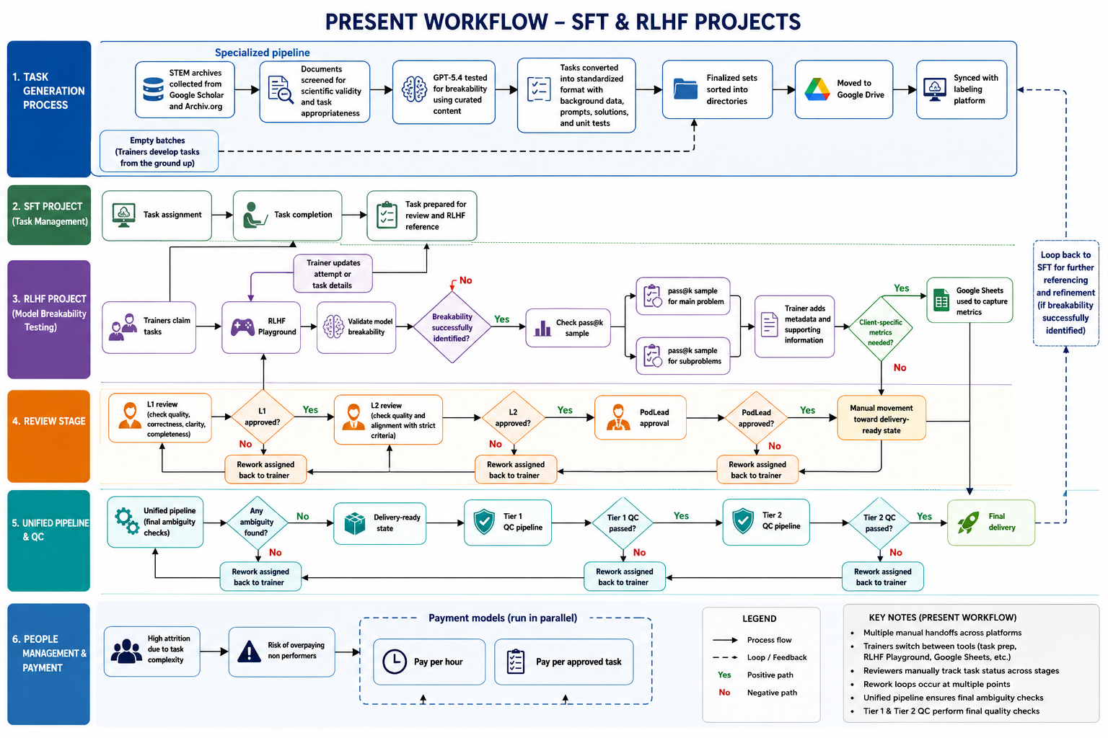

Proposed Flow
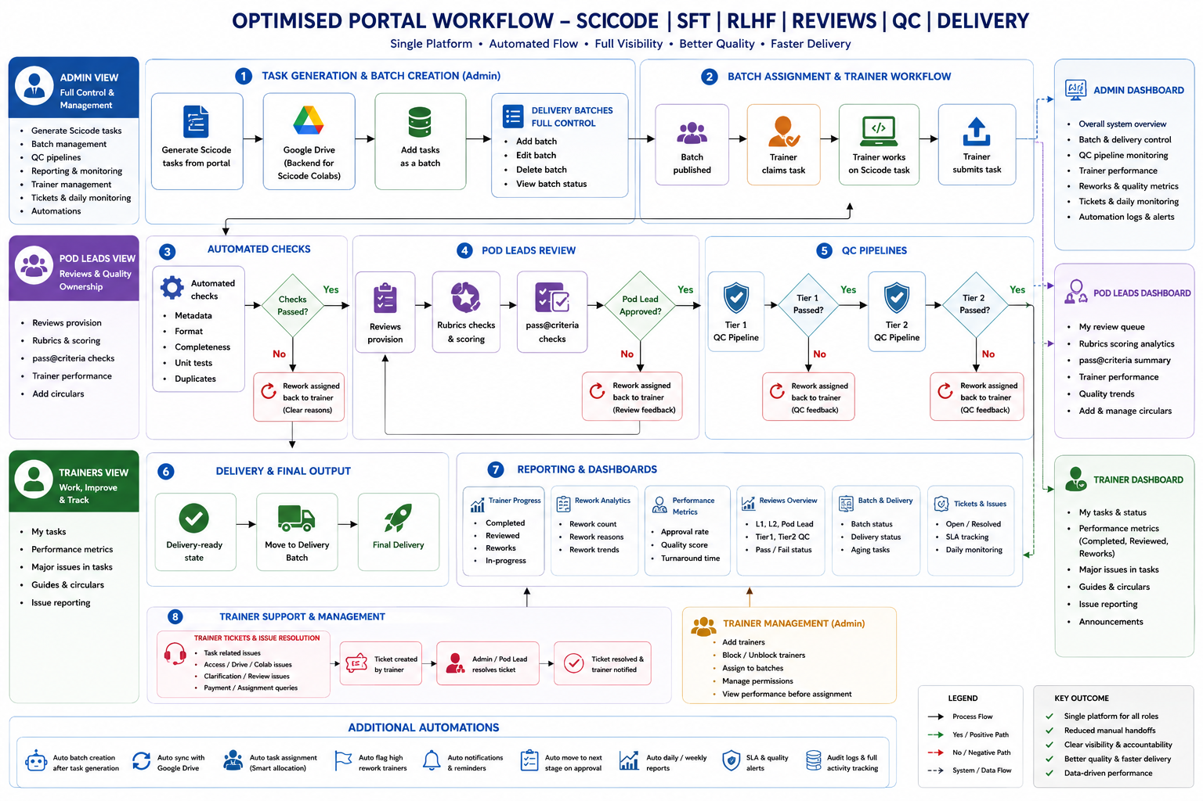

Additional Reference Materials

- Trainer Technical Manual (HTML Format)
https://sites.google.com/turing.com/msscicodev2/home

- Reviewer Guidelines [L1 and L2] : Link

